Experiment 1 — Exploratory Data Analysis (EDA)

Name : Prem V Hanchate
Roll no: 68 Class: TE/IT

Aim
To perform Exploratory Data Analysis (EDA) on the Aadhar Enrollment dataset to understand its structure, detect and treat missing values, and summarize key statistical properties using descriptive measures such as mean, standard deviation, min, max, and quartiles.

Theory
Exploratory Data Analysis (EDA) is the process of systematically examining a dataset before applying any formal modeling or statistical inference. It helps in understanding the nature of data, finding patterns, spotting anomalies, and checking assumptions.
1. Data Loading and Preview: The dataset is loaded into a pandas DataFrame from an external file (Excel/CSV). The head() function is used to display the first few rows, giving an initial overview of the data — its columns, values, and general structure.
2. Dataset Dimensions: Understanding the size of the dataset is fundamental. The shape attribute returns the number of rows (records) and columns (features). For the Aadhar dataset, rows represent individual enrollment records and columns represent attributes such as demographic details, registration status, and enrollment statistics.
3. Descriptive Statistics: The describe() function generates a statistical summary for all numeric columns. Key measures include:
- Mean — Average value of a column, representing central tendency.
- Standard Deviation — Measures how spread out the values are from the mean.
- Min / Max — The smallest and largest values observed in a column.
- Quartiles (25%, 50%, 75%) — Divide the data into four equal parts; the 50th percentile is the median.
These statistics give a quick sense of the scale, range, and distribution of each numeric attribute.

4. Data Type Information: The info() function provides column-wise details including data types (int, float, object), non-null counts, and memory usage. This helps identify columns that may need type conversion or special handling.
5. Missing Value Detection: Missing values (NaN) are common in real-world datasets and can arise from incomplete data entry, system errors, or unavailable records. The isnull().sum() function returns the count of missing values per column, helping identify which columns require treatment.
6. Missing Value Treatment (Imputation): Once missing values are detected, they are filled using the fillna() method. For numeric columns, the mean of the respective column is used for imputation. Mean imputation is a standard technique that preserves the overall distribution without drastically altering summary statistics.
7. Verification: After imputation, isnull().sum() is run again to confirm that no missing values remain in the dataset, ensuring data quality before any further analysis.

Execution
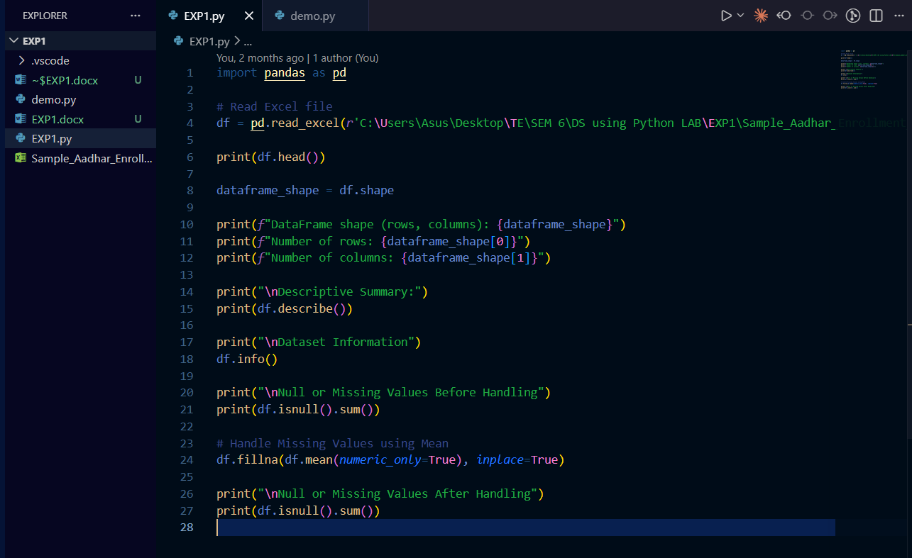
Output
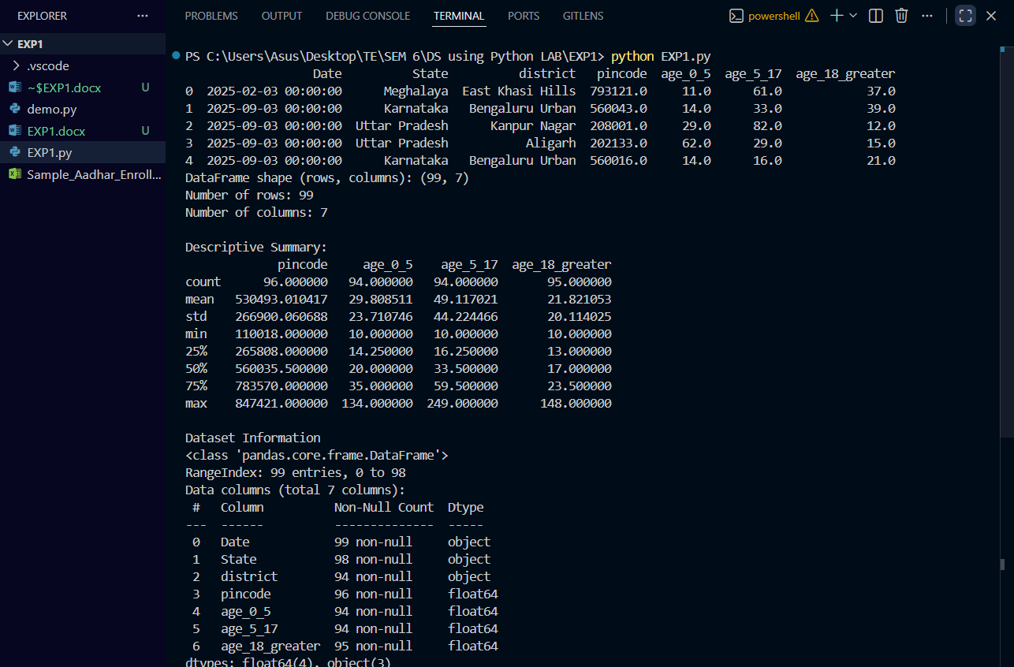
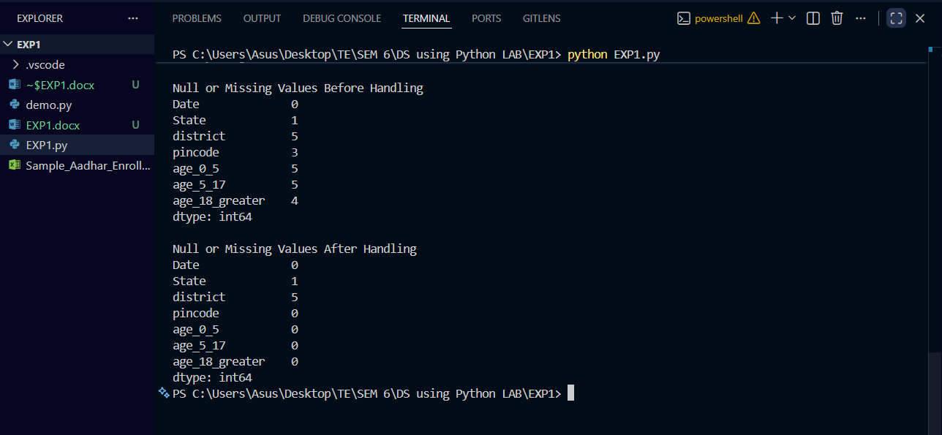
Conclusion
In this experiment, Exploratory Data Analysis (EDA) was performed on the Aadhar Enrollment dataset. The dataset structure, data types, and statistics were analyzed using functions like head(), shape, info(), and describe(). Missing values were identified and handled by replacing them with the mean of numeric columns using fillna(). After cleaning, the dataset became free of null values and ready for further analysis or machine learning tasks.

